December 30, 2014

Dear Friends,

This 30th issue of the *Theological Research Report* brings us to the end of seven years of publication. This issue is complementary to and completes the evidence regarding the Calculated Hebrew Calendar presented in Issue 29, which our branch of the Church of God has used since 1936—a period of 77 years.

The period of time covered by the 19 Exhibits presented in these two issues begins with the Great Flood of Noah in 2369 BC and extends to the year 1940 AD—a period of 4,309 years. Each of the 19 Exhibits found in Issues 29 and 30 is submitted as evidence of the calculation of the *Molad of Tishri* by the application of the Rules of Postponement and 7 years of intercalation in every 19-year cycle. This cycle is known as the Metonic Cycle, however, the 19-year cycle was known many millennia before the Greeks. The Scriptural record of the Flood verifies that the 19-year cycle of intercalation was in effect as far back as 2369 BC. It has remained in continuous effect to the beginning of the year 2015 AD—a period of 4,382 years.

My study of the inner workings of the Hebrew Calendar began very early in life. I was 15 when I first listened to Herbert W. Armstrong in 1956. Two of the earliest doctrines I accepted and began to live by were the weekly Sabbath and the annual holy days. I had no one to fellowship with at that time as the closest church was in Chicago. I remember receiving my copy of the holy day calendar for the coming year. The dates of the holy days were taken from Arthur Spier’s book *The Comprehensive Hebrew Calendar* and were printed in the same format as that of Spiers.

In June of 1959 I graduated from high school, and in late August I boarded a Greyhound Bus in my hometown in Southwestern Michigan and headed for Pasadena, California. I was 17 at the time and eager to learn all the truths of God’s Word that were being taught in those early years of Ambassador College.

The bus arrived in Chicago where I transferred to another bus and continued west. I arrived in the Los Angeles area after a three-day ride in that crowded bus. During the last leg of the trip I sat between two marines at the rear of the bus. The marines were in dress uniform, and I was wearing a wool suit. For about 1000 miles we sat directly above the bus engine with all its noise and heat.

We arrived in the Los Angeles area on the afternoon of August 25. I hastily got off the bus somewhere in the City of Alhambra after seeing a sign pointing to Pasadena in the opposite direction that the bus was headed. In my panic, I left my luggage on the bus. I desperately needed to reach someone at Ambassador College, and I had only two dimes in my pocket. The first call was a wrong number. Thank God, my last dime rang through to the Ambassador College switchboard. What a relief to hear the voice of Karen Armstrong, wife of Dwight Armstrong.

Before long Al Dennis pulled to the curb to pick me up. With him was another stranded student, Marilyn Russell from Texas. We soon arrived at the Ambassador Campus. I was assigned to a men’s dorm which had been converted from a small house at the foot of Ambassador Hall. There I was introduced to my dorm mates: Fred Kellers, August Rubrecht, Tom Lavendar, Clarence Huse, Roy Holladay and Leroy Cole, the younger brother of Raymond and Wayne Cole. Arthur Kirishian was our dorm monitor.

About seven weeks after arriving on campus, the entire student body boarded buses and headed for Big Sandy, Texas, to attend the Feast of Tabernacles. The Feast began on the Sabbath of October 17. I remember the first High Sabbath very well, as Roy Holladay and I were rooming with six or seven others in one of the new booths at the festival site.

We were running late to get to the introductory service that Friday night of October 16, and I literally ran across hill and dale behind Roy. When Roy jumped a small creek, I did not see it and ran right through it. I sat in the midst of 5000 brethren on that hot Texas night in my steaming wool suit as a minister’s voice boomed out, “Welcome, brethren, to the 1959 Feast of Tabernacles.” I remember a remarkable sermon by David Jon Hill about making excuses, titled “Ya But.” Mr. Hill concluded his dynamic message with an exhortation urging all of us to “get off our buts.”

During the Feast, I was invited by other students to attend a movie in downtown Big Sandy. The movie was *On The Beach*–a very depressing sci-fi movie about the last remaining souls on earth who were huddled together on a remote Australian beach waiting for radioactive clouds of death which were slowly approaching. What doom and gloom! If I could have done so, at that moment I would have boarded a bus back to Dowagiac.

I somehow survived this early period, and I began to thrive on the wonderful truth of God that I had come to Ambassador College to learn and live by. One of those truths, one of the most important of all, I studied in Third Year Bible Class. That school year was, I believe, 1962. Third Year Bible was one of the classes required for graduation. Every student who completed four years of study at Ambassador College took this class. It was one of the toughest classes I took at Ambassador and was taught by Dr. Herman L. Hoeh.

One of the most important subjects we studied was the mathematical underpinning of the Hebrew Calendar. We were taught how to calculate the *Molad of Tishri*, the lynch pin of the entire calendar. After we calculated this date and time, we learned to calculate the date of Nisan 14, which begins the feast season each year, by counting 164 days back from Tishri 1. The first High Sabbath of Unleavened Bread always fell on Nisan 15 and the last High Sabbath of Unleavened Bread always fell on Nisan 21. The fall festival season was a simple count forward from Tishri 1 because Atonement always fell on Tishri 10, the first High Sabbath of Tabernacles always fell on Tishri 15, and the Last Great Day always fell on Tishri 22. Pentecost was not as simple as it required a 50-day count from the Wave Sheaf Day, which fell on different dates during the Days of Unleavened Bread.

Dr. Hoeh gave all his Third Year Bible students an 8-page handout that explained the mathematical steps necessary to calculate the *Molad of Tishri*. These computations were in simple arithmetic that was being taught to 6th grade students in elementary schools across the nation.

The pages of this handout are open before me on my desk as I write. I compiled them many molads ago, along with other college documents, and had them bound in book form. This book, titled *Study Aids*, still sits on my library shelf.

At the beginning of this short handout, Dr. Hoeh cited as his source for the calendric information the *Britannica* article “Calendar.” No edition was given, but years ago I tracked the article down while researching at the James White Library, Andrews University, in Berrien Springs, Michigan. The article, published in the 14th edition of the *Britannica,* was very complete and surprisingly detailed. The editors of the *Britannica*, as it turns out, had gleaned most of their material for the article from a book published in London in 1838. This book, written by E. H. Lindo, Esq., was titled *A Jewish Calendar for Sixty-Four Years*, *Detailing The New Moons* [the calculated Molads]*, Festivals and Fasts*. Tables for continuing the calendar to A.M. 6000-2240 AD were added. (See Screens 1 and 2 on Page 6 of this letter).

I call your attention to a chart constructed by Mr. Lindo and published on Page 10 of his book. (See Screen 3 on Page 7 of this letter.) This table is composed of 7 columns labeled from left to right:

Name of the Month

Day of the Week

Hours

Min.

Sec.

Thirds

Day of the New Moon

The Hebrew months in the table begin with Tishri, civil year 5607 (1846 AD), and run forward in time to Tishri, civil year 5608 (1847 AD).

The calculated time of the *Molad of Tishri* is listed as follows (See first row of numbers in Screen 3 on Page 7.):

Day of the Week 2, Hour 0, Min. 31, Sec. 23 and 1 Third

Below these figures is a second row of numbers:

1 12 44 3 1

This second row of numbers is derived from the average length of the monthly conjunction of the moon (29 days) by “throwing out the weekly sevens” (7x4=28), leaving a remainder of 1 (29-28=1). This number represents a forward movement of one day in the weekly cycle from Tishri 1 to Hesvan 1.

Lindo calculates successive calendar months by adding the numbers 1-12-44-3-1 to the time categories of each month to arrive at the next date of Tishri 1. He does not calculate backward to Passover, but forward through the fall holy day season to the spring holy day season, and on to Tishri 1 of the next year.

As a close friend recently said to me, “It doesn’t matter if we count backward or forward as long as we begin with the calendric lynch pin of Tishri 1. Without calculating Tishri 1 we are literally lost in space.”

Notice that the names of the Hebrew months in Screen 4 on Page 7 are anglicized (except for Iyar) and are not spelled as they are today in Jewish Calendars commonly found on the Internet. Notice also that the cycle of intercalary years in Screen 5 on Page 8 is the same 3323332 cycle that we utilize today in our Calculated Hebrew Calendar.

I would send Lindo’s book to you by attachment if I could, but it is too large (nearly 15 MB). However, you may download your own copy from the Internet Archive project sponsored by a consortium of companies and universities led by Google.

It is our hope and prayer that the material presented in Issues 29 and 30 will strengthen your faith by grounding you even more firmly in the great blessing that God the Father and Jesus Christ have given us, the Calculated Hebrew Calendar, which enables us to feast and fellowship in unity with them on their appointed days.

Warmest regards,

Carl and Jeanie Franklin

Screen 1

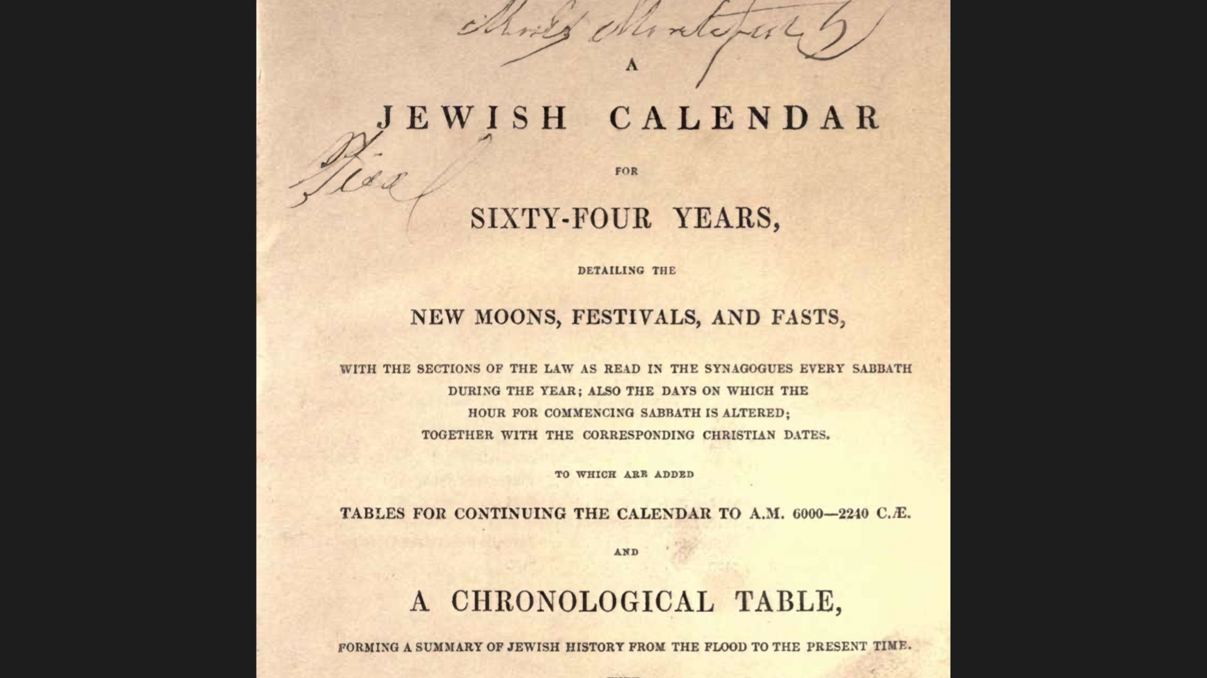

Screen 2

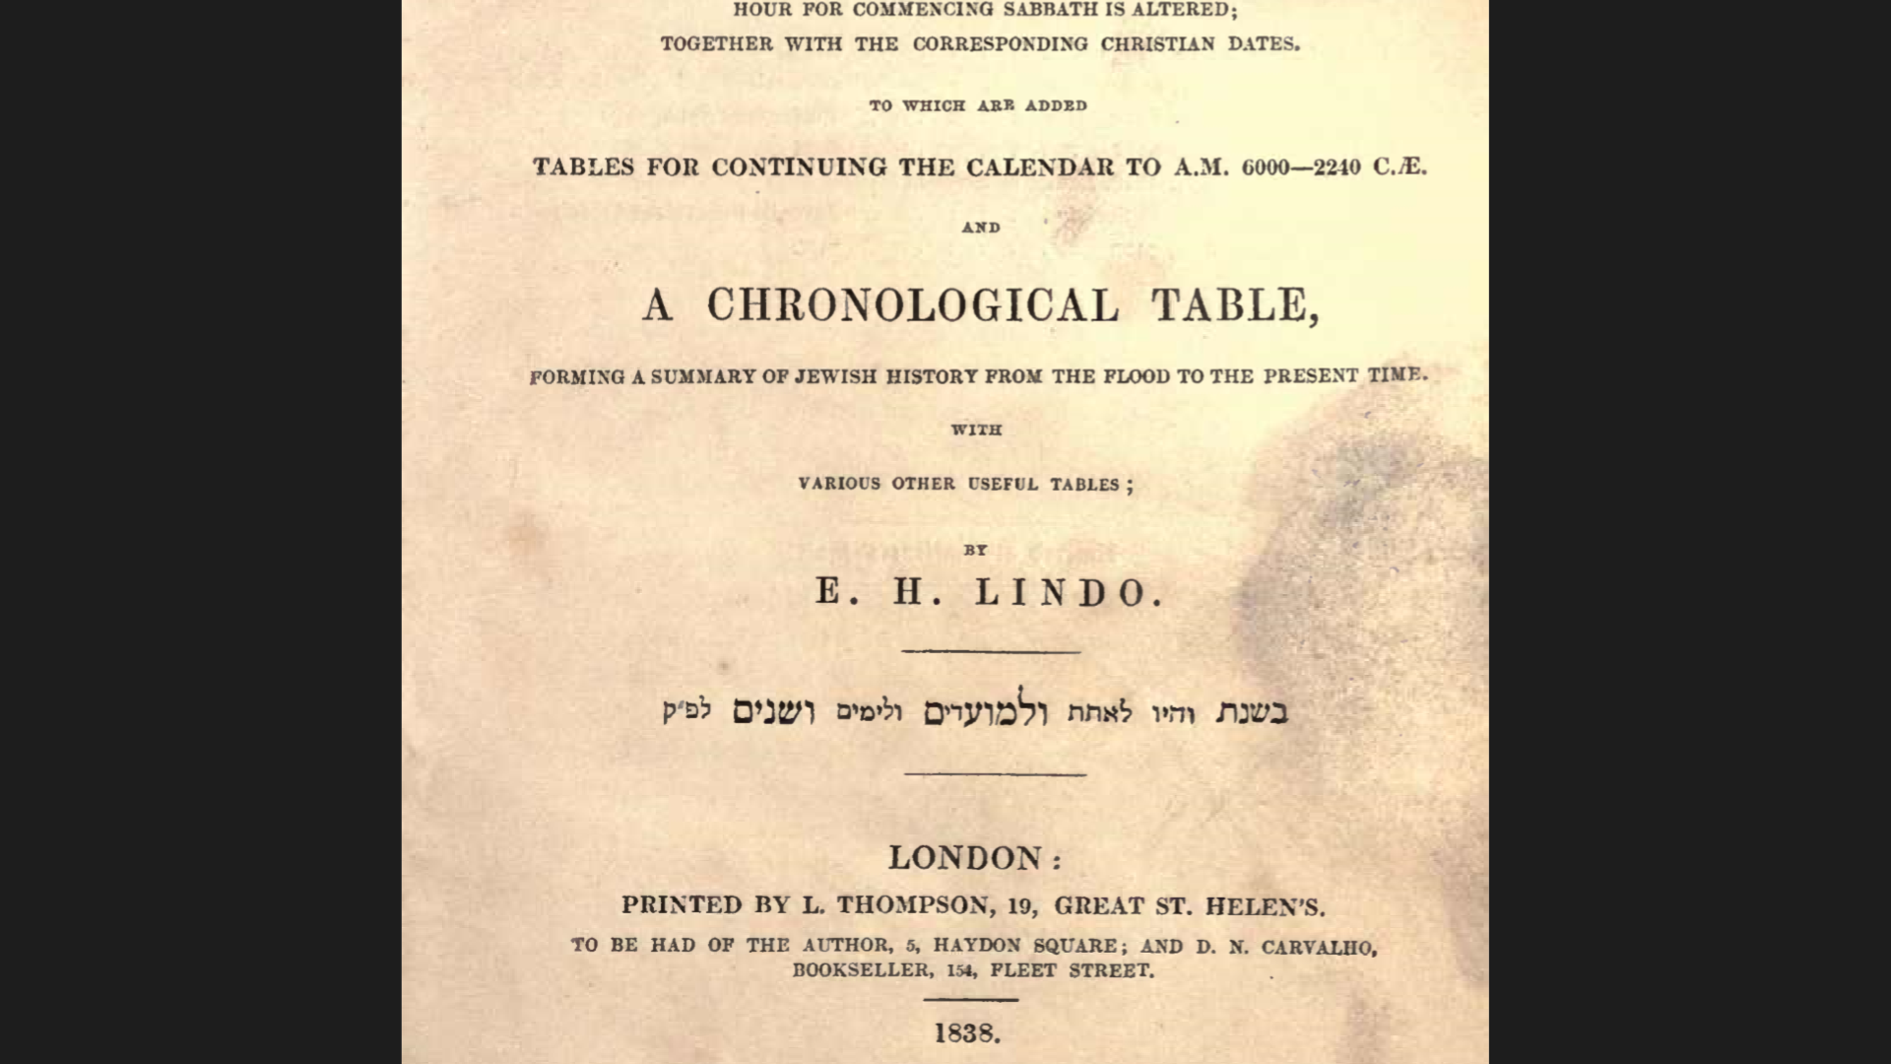

Screen 3

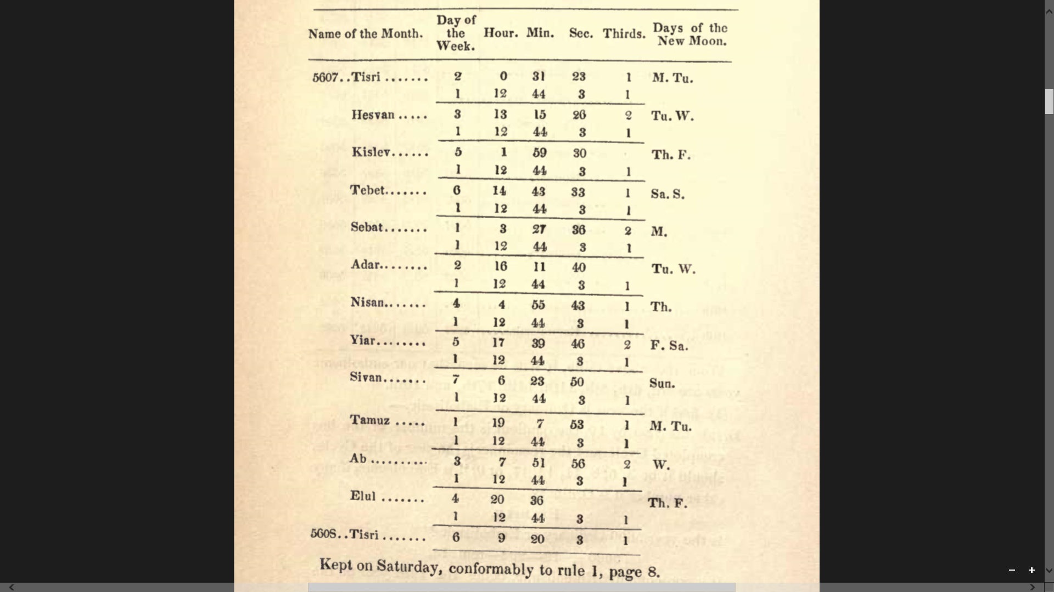

Screen 4

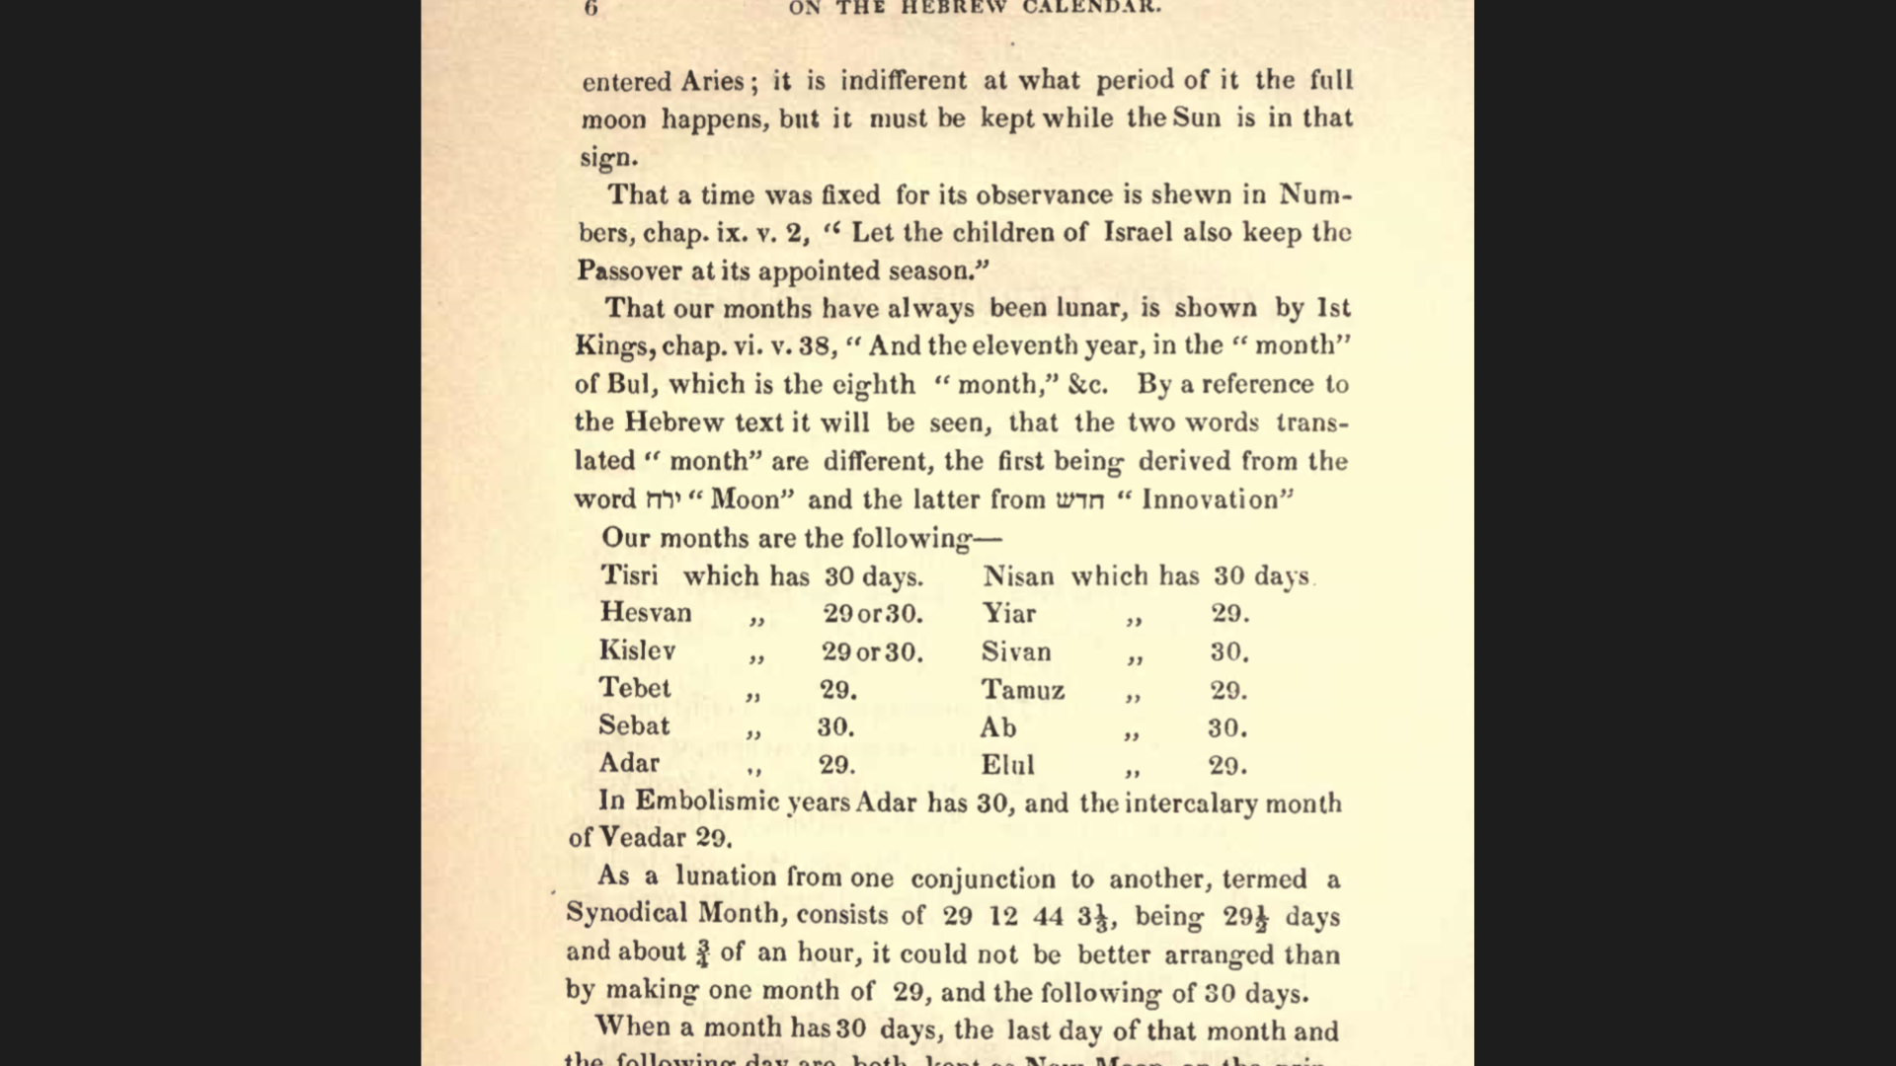

Screen 5

